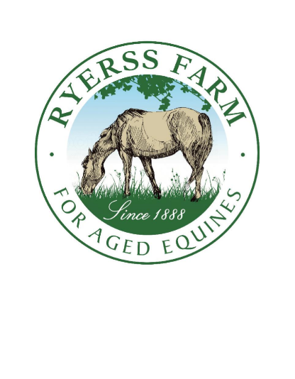
Ryerss Farm
134th Birthday Party
A Special Thank You to our Event Sponsors!
Alice & David Sharp Ann & Robert Lee
Bill & Gail Mower Charlene & Rob Tucker
Circle of Support Douglas Barr
Dr. Frank Riley Eileen M. Corl
Elizabeth Almeida Gail F. Large
Holly Griffin Ivan Morris (In Memory of Gail Morris)
Jay & Phillis Pillard Jodi D. Bremerton
Judith Cooke Karyn & Jeff Ziser
Kathryn Burkart Lynn Seeburger
Lisa Segui Marion Pedrick
Nancy Erickson Nancy Schwab
Pam Ginsberg Pamela Haskin
Penelope & Thomas Watkins Peter & Stephanie Giangiulio
Rita Warner Robert & Ann Lee
Samuel Griffin Sarah Milam
Susan Martin VCC Healthcare Solutions
Wes & Mary Hardin Wiederseim Associates, Inc.
Boothwyn Pharmacy

